2303A51910
LAB-2.1
Task 1: Statistical Summary for Survey Data
Scenario:
You are a data analyst intern working with survey responses stored as numerical lists.
Prompt :
“Generate a Python function that accepts a list of numbers and calculates the mean, minimum, and maximum values. Display the output clearly.”
Code & Output:
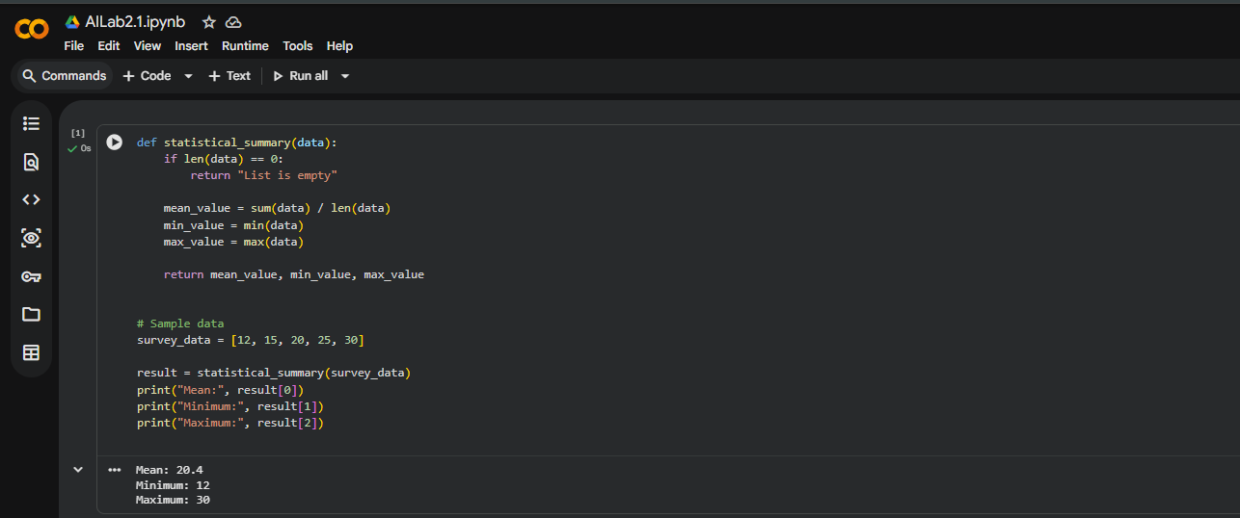

Justification
- Gemini generated clean and readable code
- Used built-in Python functions for efficiency
- Included input validation
- Suitable for data analysis tasks

Task 2: Armstrong Number – AI Comparison
Scenario
Evaluating AI tools for numeric validation logic.

Prompt :
Gemini Prompt
“Write a Python program to check whether a number is an Armstrong number.”
GitHub Copilot Prompt
“Create a function to validate Armstrong numbers in Python.”

Code & Output:
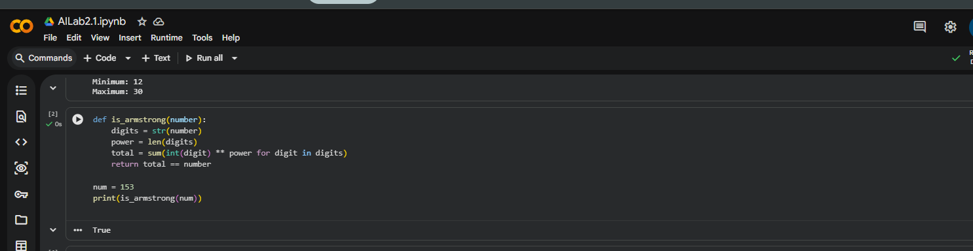
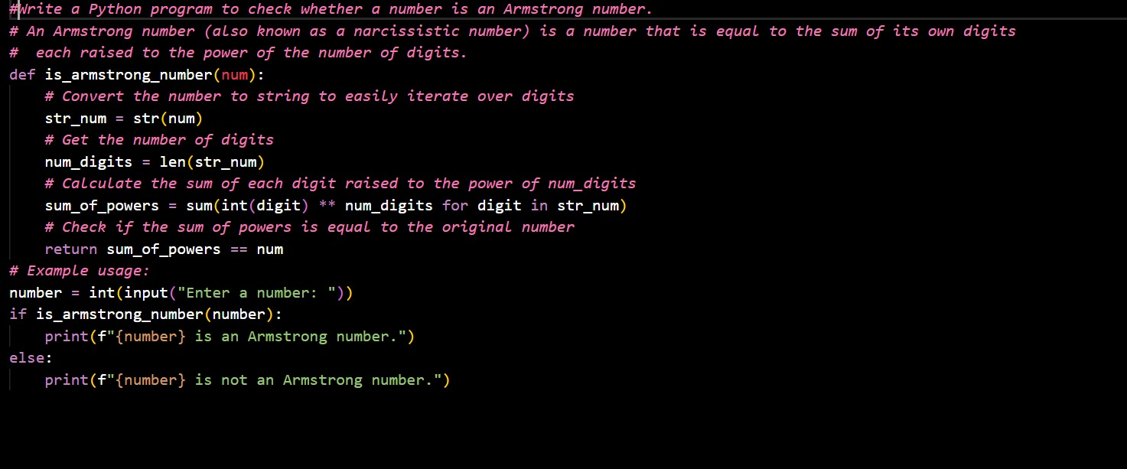
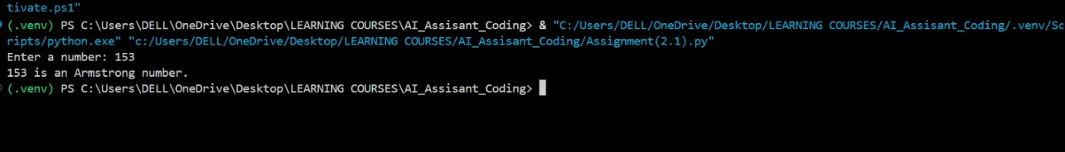

Justification
- Gemini provides concise and modern Python
- Copilot uses classic logic, better for understanding fundamentals
- Both are correct and efficient

Task 3: Leap Year Validation
Prompt 1
“Write a simple Python program to check whether a given year is a leap year.”
Prompt 2
“Create a reusable Python function to validate leap years using standard leap year rules. Optimize the code and make it readable.”

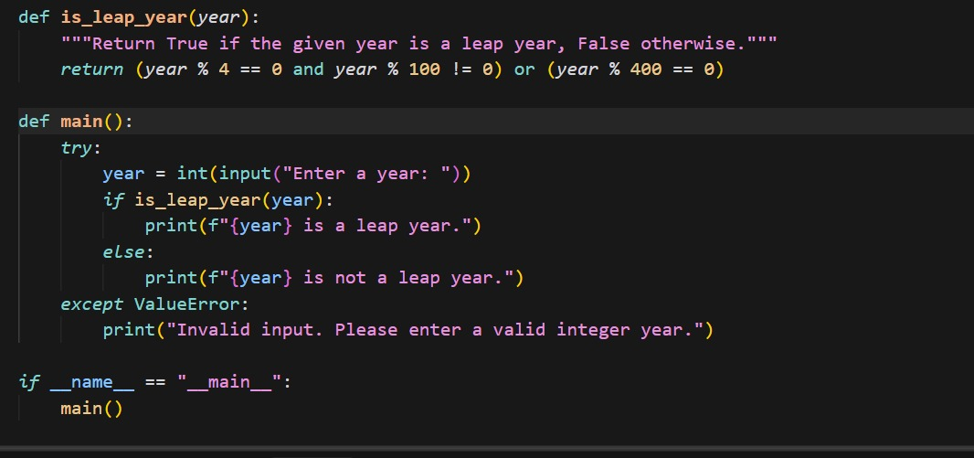
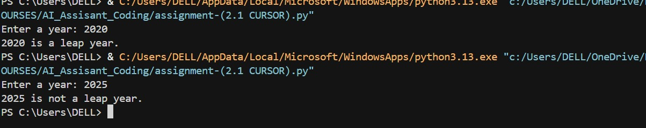

Justification
- Cursor AI adapts code based on prompt depth
- Second version follows best practices
- Suitable for backend modules

Task 4: Student Logic + AI Refactoring (Odd/Even Sum)
Prompt 1: Student Logic
“Write a Python program that calculates the sum of odd numbers and the sum of even numbers from a given tuple of integers.”
Code & Output:
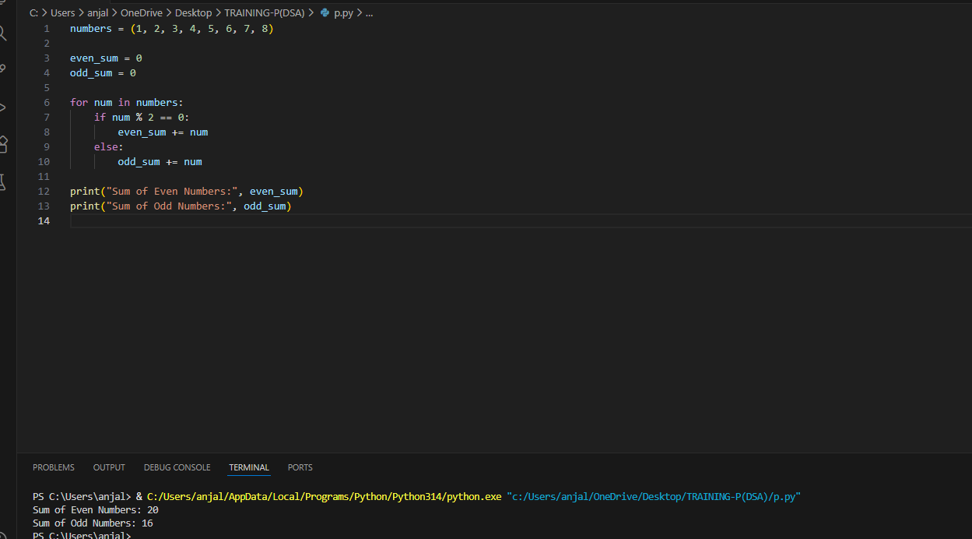
“Explain the improvements made in the refactored code and why they are better than the original version.”
Prompt 2: GitHub Copilot
Refactor and optimize the following Python code that calculates
the sum of odd and even numbers in a tuple.
Use Pythonic constructs and improve readability.
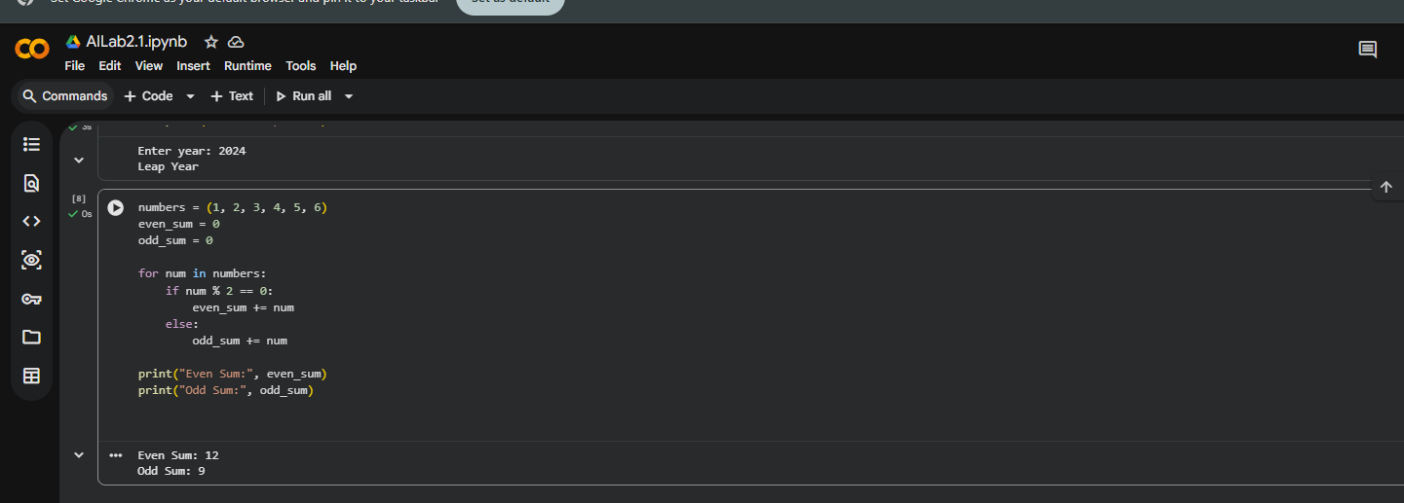

Justification:
Reduced lines of code
Used Python generator expressions
Improved readability and performance
Follows modern Python standards

